Question no-1: Write a C program to read and print elements of array

#include <stdio.h>

int main() {

int n, i;

printf("Enter number of elements: ");

scanf("%d", &n);

int arr[n];

printf("Enter %d elements:\n", n);

for(i = 0; i < n; i++) {

scanf("%d", &arr[i]);

}

printf("Array elements are:\n");

for(i = 0; i < n; i++) {

printf("%d ", arr[i]);

}

printf("\n");

return 0;

}

**Output:**

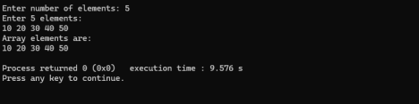

Question no-2: Write a C program to print all negative elements in an array.

#include <stdio.h>

int main() {

int n, i;

printf("Enter number of elements: ");

scanf("%d", &n);

int arr[n];

printf("Enter %d elements:\n", n);

for(i = 0; i < n; i++) {

scanf("%d", &arr[i]);

}

printf("Negative elements in the array are:\n");

for(i = 0; i < n; i++) {

if(arr[i] < 0) {

printf("%d ", arr[i]);

}

}

printf("\n");

return 0;

}

**Output:**

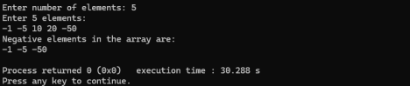

Question no-3: Write a C program to find sum of all array elements. #include <stdio.h>

int main() {

int n, i, sum = 0;

printf("Enter number of elements: ");

scanf("%d", &n);

int arr[n];

printf("Enter %d elements:\n", n);

for(i = 0; i < n; i++) {

scanf("%d", &arr[i]);

}

for(i = 0; i < n; i++) {

sum += arr[i];

}

printf("Sum of all array elements = %d\n", sum);

return 0;

}

**Output:**

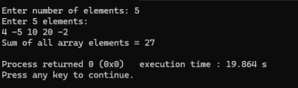

Question no-4: Write a C program to find maximum and minimum element in an array.

#include <stdio.h>

int main() {

int n, i, max, min;

printf("Enter number of elements: ");

scanf("%d", &n);

int a[n];

printf("Enter elements: ");

for(i = 0; i < n; i++) scanf("%d", &a[i]);

max = min = a[0];

for(i = 1; i < n; i++) {

if(a[i] > max) max = a[i];

if(a[i] < min) min = a[i];

}

printf("Max = %d\nMin = %d\n", max, min);

return 0;

}

**Output:**

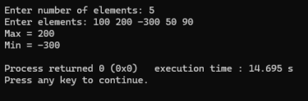

Question no-5: Linear search

#include<stdio.h>

int main(){

int flag =0, i, search_value, a[20] = {10,2,-1,0,-3,9};

printf("Enter search value: ");

scanf("%d", &search_value);

for(i=0; i<6; i++){

 if(search_value == a[i]){

 flag = 1;

 break;

 }

}

if(flag == 1){

 printf("Value is found");

}

else{

 printf("Value not found");

}

return 0;

}

**Output:**

